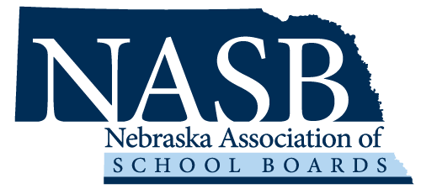 Information Technology Specialist

Nebraska Association of School Boards (NASB), www.nasbonline.org, is a private, non-profit association serving school board members across the state of Nebraska. NASB provides an array of services to our more than 1600 members. Our growing Association is seeking a dynamic and tech-savvy individual to join our team.

Job Description

The Information Technology Specialist is pivotal in maintaining the seamless operation of our office technology. The Specialist will provide technical assistance to the staff and provide additional training and education when needed.

Essential Functions

- Desktop and Hardware Support
- Provide on-site technical support for desktop hardware and software issues.
- Install, configure, and troubleshoot computer systems and peripherals.

- Software Support and Expertise
- Assist team members with software applications, offering guidance on installation, troubleshooting, and usage.
- Collaborate with the IT team to manage software licenses and updates effectively.

- Proactive Hardware Maintenance
- Conduct routine maintenance on computer systems and peripherals for optimal performance.
- Coordinate with vendors for hardware repairs and replacements.

- User Account Management
- Manage on-site user accounts, permissions, and access levels.
- Monitor and address security concerns related to user accounts.

- Responsive Help Desk Support
- Respond promptly and professionally to in-person help desk tickets and inquiries.
- Prioritize and escalate issues as necessary to ensure timely resolution.

- Comprehensive Documentation
- Maintain accurate and up-to-date documentation of technology systems, procedures, and user guides.

- Empowering Training Sessions
- Conduct engaging in-person technology training sessions for employees as needed.
- Develop comprehensive training materials to support ongoing technology education.

- Coordinates and develops customizations in Dynamics 365 and other web-based data management systems to meet the needs of NASB.

Qualifications

- Bachelor's degree in Information Technology, Computer Science, or a related field is preferred but experience in lieu of education will be considered.
- Genuine interest in technology with a strong willingness to acquire new skills.
- Exceptional problem-solving and communication abilities.
- Comfortable working in an in-office setting and collaborating in a fast-paced environment.
- Basic understanding of networking concepts and protocols is advantageous.

Benefits:

NASB will provide you with a competitive salary, 401k (10% employer contribution with a possible 3% match), health and dental, vision, life insurance, long-term disability, 11 paid holidays, vacation, sick, and bereavement leave, summer hours in June and July (office closes at 2 p.m. each Friday with full pay for the day), wellness and staff activities on a regular basis, paid professional membership and professional activities (conferences and workshops), tuition reimbursement program, flexible spending account for medical and dependent care reimbursement. Possible bonuses dependent on the success of any given fiscal year.

Please submit the following by May 10th to Sallie Horky, Chief Operating Officer, at shorky@nasbonline.org

Cover Letter and Resume
References – 5 professional references (prefer co-workers)
College Transcript
Application for Employment (request the form from Sallie Horky)

